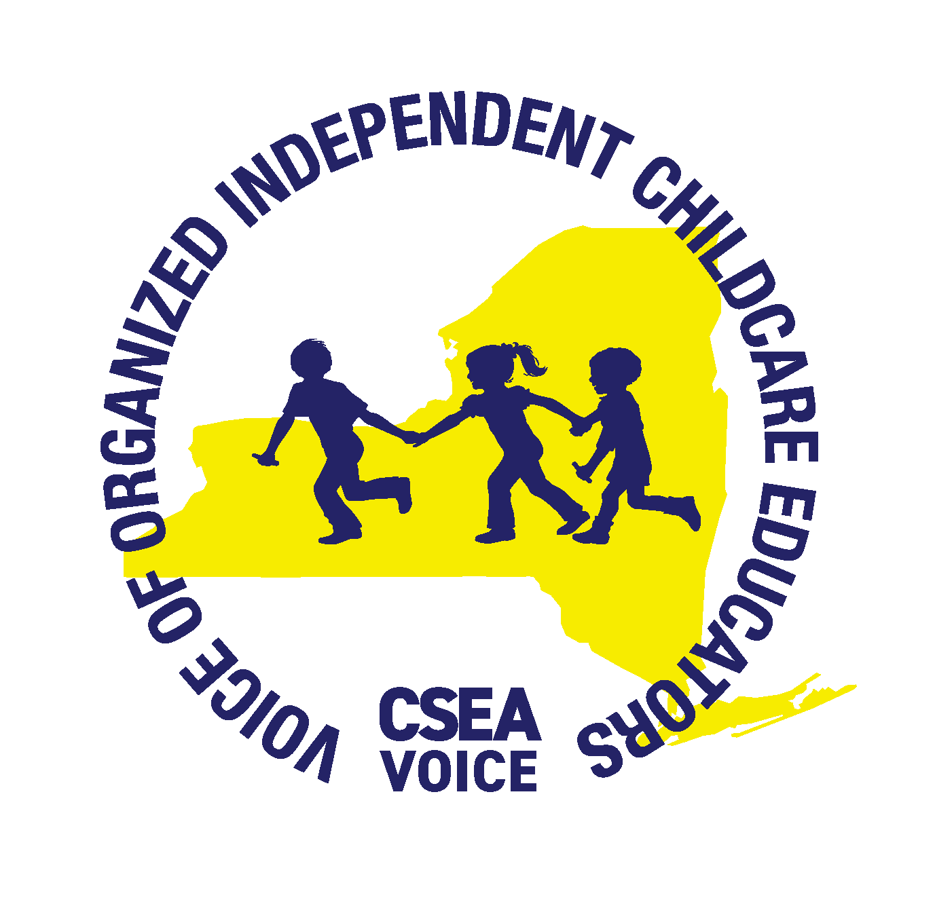
CSEA/VOICE
CDA SCHOLARSHIP REIMBURSEMENT
APPLICATION

Complete this form and mail it to the CSEA WORK Institute, 1 Lear Jet Lane, Suite 5, Latham, NY 12110.
Call the CSEA WORK Institute at (518) 782-4427 or (866) 478-5548 (areas outside the Capital Region) if you have questions about any of the information requested. You may apply for UP TO $3100 in reimbursement for Child Development Associate Credential (CDA) for course expenses incurred between 10/1/25-9/30/27. All applications must be received (not postmarked) by September 30, 2027.

You are eligible if you are a NYS Registered Family or Licensed Group Family childcare provider outside of New York City.

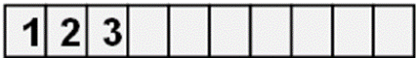
CSEA ID Number: 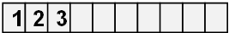 Social Security Number: 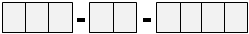

Daycare Registration/License Number:

Name:

Mailing Address:

City: State: Zip code:

Daytime Phone: ( ) Ext.

Email address:

Please check the appropriate box below to identify the expense for which you are seeking reimbursement.
CDA Course □ CDA Application Fee □ CDA Renewal Fee □

Please include a copy of your invoice or receipt showing payment to Council for Professional Recognition and/or training organization (including proof of course completion) and copy of CDA Credential (if applicable).

CDA COURSE REIMBURSEMENT School Name:

Course Number and Title:
DO NOT LEAVE BLANK!
Number of credits

What is the start date of the course? What is the end date of the course?

All the information contained in this application is true and accurate to the best of my knowledge and belief. My signature below indicates that I understand that I am not receiving reimbursement from the CSEA/VOICE Tuition Assistance Program nor from the NYS Child Care Educational Incentive Program (EIP) for the same expenses for which I am requesting reimbursement. I understand that I must repay the monies if I, in any way, provide false information.

Signature: Date:

