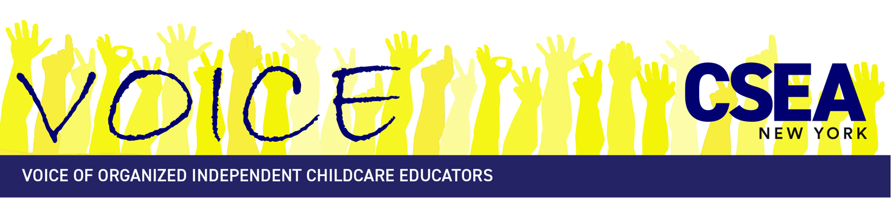
c/o CSEA Organizing Department
1 Jet Lear Lane, Latham, NY 12110
(877) 483-CSEA
e-mail: voice@cseainc.org
website: www.voicecsea.org

To: CSEA VOICE Members
From: CSEA VOICE Negotiations Team
Date: October 26, 2026

We are writing with exciting news! Thanks to our strong base of dues-paying members, we have reached a fifth Tentative Agreement with the NYS Office of Children and Family Services (OCFS) that exceeds our expectations in these hard times for child care educators and working families.

We are hosting very important Statewide Informational Zoom Meetings on November 17th, 2026 at 12:30pm, and November 18th, 2026 at 6:30pm.

We will discuss highlights of the five-year agreement (October 1, 2026 through September 30, 2031) including:
- $2 million annually in a retirement fund starting in 2027 alongside the creation of a committee to conduct a study and advise on retirement benefits.
- Increasing funding for professional development
- Increased funds for Quality Grants, including funding for a dual language program award.
- Direct pay from OCFS to educators caring for children in the parent’s home where possible.
- A mentorship program for Legally Exempt Child Care educators.
- Continued funds for health insurance rebates, vision and dental coverage, and telemedicine benefit to educators and household members.
- Opportunities to better emergency preparedness recourses and procedures
- An opt-out option to publicly accessible contact information on state website

Since organizing in 2007, we have built a strong union that supports child care educators to deliver early learning and care. We’ve taken action and continue to accomplish goals set by our members at chapter, regional, and statewide levels.
We have supported and jumpstarted:
- 20 program closure days for registered and licensed programs, with an optional 2 days that can be used for professional development
- Increasing subsidy rates paid to educators
- Expanding childcare facilitated enrollment statewide
- Comprehensive health benefits & increased professional development opportunities
- Paying for a statewide maximum of 80 child absences per year
- Requiring 12-month eligibility determinations for parents
- Limiting family copayments to 1% statewide

These only get better in this contract.

Working with CSEA, thousands of educators built this union and accomplished so much, in part, because we had sufficient money to pay for the cost of running a statewide organization.
Union dues pay for the CSEA Child Care Resource Center, conference calls, mailings, lobbying, legal assistance, member trainings and meetings. Dues are 2% of subsidy reimbursements, up to a cap. Dues are a fully tax-deductible business expense. When you join and pay dues, you enjoy all the rights and privileges of union membership: voting on agreements; access to member-only business liability, homeowner and disability insurance; discounts and programs; voting and running for union office; and participating in chapter, regional and statewide meetings, actions and trainings.

CSEA/VOICE gives home-based child care educators power and resources they never had before to safeguard family child care and sustain their businesses. With a strong membership base, our union will continue to negotiate and deliver support and services to educators across New York.

Only CSEA/VOICE members in good standing may vote on this Agreement. We will be voting using Election Buddy. We will send you links and directions on how to vote via email.
For more information on this agreement, visit our website at https://voicecsea.org/our-contract/
For more information about CSEA/VOICE, call the CSEA/VOICE Child Care Resource Center toll free at (877)483-2732 or email voice@cseainc.org .

In Solidarity,
The CSEA/VOICE Local 100A Negotiations Team

